SWEET AND SOUR CHICKEN WITH EGG FRIED RICE 400G – LEAN- same method for Penang

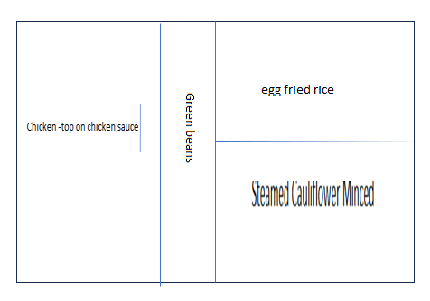

For Large and Standard products
